(Approx. 1,658 words)

SkyDrive & Office Web Apps
By Lynn Page, Editor/Webmaster, Crystal River Users Group, FL
March 2013 Newsletter issue
www.crug.com
lpage46 (at) tampabay.rr.com

With a Windows Live ID you have access to Microsoft’s Office Web Apps. This lets you open, edit and share Word, Excel and PowerPoint documents online using SkyDrive. So you can work with your documents from any computer whether it has the Office applications installed on it or not. Go to http://skydrive.live.com in a web browser to log on or sign up for a Windows Live account.

Store Office documents on SkyDrive to view and edit them in a browser. Or share documents stored on SkyDrive by linking to them in an email, blog or social network.
Save to or Upload to SkyDrive Documents generated on your home computer can be saved to SkyDrive or uploaded. Use Save & Send to save an existing Word, Excel, or PowerPoint file. Select Save to Web, Sign in to your Windows Live Account, and then click OK. Specify a folder on SkyDrive, and click Save As. Type a name for the file and click Save.

I think it is easier to create the document save it on the hard drive and then upload it to SkyDrive. In the SkyDrive menu bar click Upload. Then either drag and drop files from your Documents folder to the upload box or browse to and select them for upload. To open a document in SkyDrive, select the folder where document is saved, and click the file name.

Create New Documents in the Web Browser
With the Office Web Apps you can create Word, Excel or PowerPoint files right in a web browser. The Office application doesn’t have to be open or even installed on the computer.

Sign into SkyDrive and click the kind of document to create in the Create drop down menu. In the dialog box type a name for the document and click the Create button.
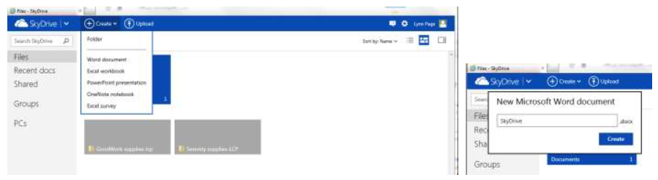

A new document opens for editing in the appropriate Web App. Simply create the document as you would in the Office application. The Web App will not have the full features of the Office 2010 application but is familiar.

Share Files on SkyDrive
SkyDrive allows you to share your Office documents, photos and other files. You can share individual files or an entire folder. In SkyDrive locate the folder or file to share and place a check in the selection box. Click Sharing on the Menu bar. The default method of sharing is by email. This lets you give specific people permission to access and even edit your files. Add the email addresses for those who will be reviewing the files, add a message and click the Share button. To access the document the recipients must have an account or create one.

The Post to option places a link to your SkyDrive files on a social media service like Facebook. I wouldn’t choose this method of sharing as it is open to any of your friends or their friends if they repost.

The Get a link sharing option creates a link you can send to others. The advantage is they do not need to have a SkyDrive account. The disadvantage is that anyone with the link can access the file. I would use the View only option for sharing a link. It allows anyone with the link see the file. The View and Edit link allows anyone with the link to see and edit the shared files. If you select Public sharing anyone can search for and view the public files.

Share Files on SkyDrive
SkyDrive allows you to share your Office documents, photos and other files. You can share individual files or an entire folder.

In SkyDrive locate the folder or file to share and place a check in the selection box. Click Sharing on the Menu bar. The default method of sharing is by email. This lets you give specific people permission to access and even edit your files. Add the email addresses for those who will be reviewing the files, add a message and click the Share button. To access the document the recipients must have an account or create one.
The Post to option places a link to your SkyDrive files on a social media service like Facebook. I wouldn’t choose this method of sharing as it is open to any of your friends or their friends if they repost.

The Get a link sharing option creates a link you can send to others. The advantage is they do not need to have a SkyDrive account. The disadvantage is that anyone with the link can access the file. I would use the View only option for sharing a link. It allows anyone with the link see the file. The View and Edit link allows anyone with the link to see and edit the shared files. If you select Public sharing anyone can search for and view the public files.

Organize/Manage SkyDrive
SkyDrive storage can be managed in a similar way as Documents on your hard drive. A new SkyDrive account will have three folders: Documents, Pictures and Public.

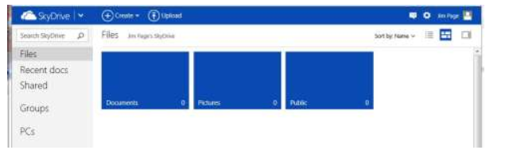

Create new folders with the Create drop down menu. Folders can be nested within these three main folders or added on the main file location. Go to the location to add a folder, click Create and select Folder from the drop down menu. Enter a name for the folder and it is all set for storing files. The path to the files or folders is shown in the title bar. The number in the bottom right corner of a folder shows the number of files it contains.

If you change your mind about how folders should be organized you can move them. To move a folder, go to it in SkyDrive. On the Mani menu click Folder actions and select Move folder to from the drop down menu. In the dialog box add a new folder or select the location to move the folder.

The Manage drop down menu is used to manage files. It allow for renaming, deleting, moving and copying files. The trick is that you must go the folder containing the file and place a check in the selection box. That opens additional commands on the Menu bar.
To move the file place a check in the selection box (top right corner), click Manage in the Menu bar and select Move to in the drop down menu. In the dialog box select the location for the file to be moved.

Word Web App
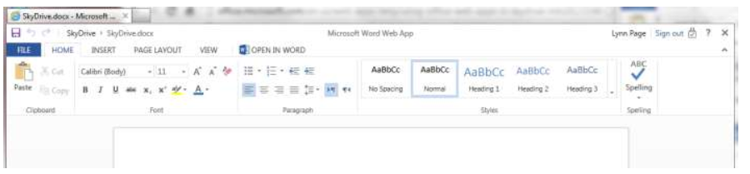

The Home tab contains basic text and paragraph formatting including Styles.

The Insert tab is used to insert tables, pictures, clip art and links. To insert a table in
the Insert Table drop down point to the number of rows and columns and click.
Clicking the Picture icon opens Windows Explorer to select a picture to insert into the
document. Browse to and select the picture and click Open. The picture is uploaded
and inserted into the document.

Clicking the Clip Art icon opens a search box. Type in a description and click the search symbol. Browse through the clip are pieces, select one and click the Insert button.
Once a picture or clip art has been uploaded a Picture Tools Format tab appears when the graphic is selected. Tools are available to Grow or Shrink the picture and add a Picture Style.

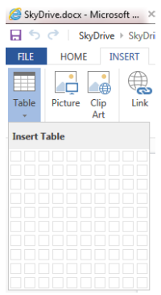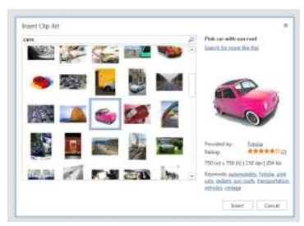

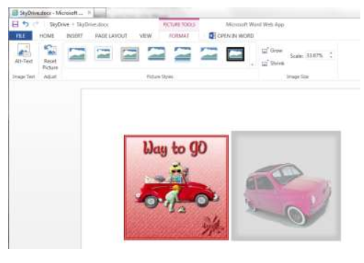
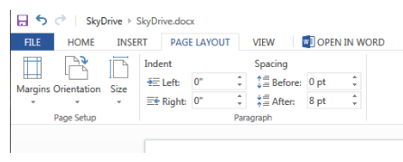

The Page Layout tab specifies page setup and paragraph indent and spacing. Page Setup options include margins, page orientation and size.

Save the document when it is complete. Clicking Save on the File tab saves it on your SkyDrive. Clicking Save As allows you to download a copy and save it on your hard drive.

Excel Web App
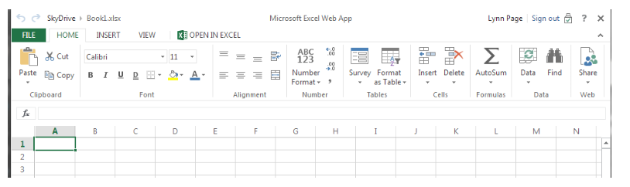
The Home tab has font formatting and alignment, number formatting and table formatting. The Cell commands allow for insertion or deletion of rows, columns, cells and new sheets. The Formulas group includes the commonly used functions. The Data group can refresh the workbook connections and recalculate or search the workbook to Find something.

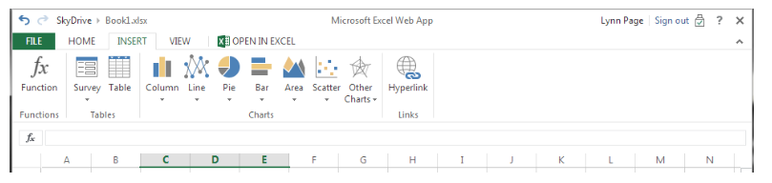
Insert Functions, Tables, Charts and Links from the Insert tab. The number of charts available is limited but sufficient.

The View tab has only two options. You can use the standard Editing View or choose Reading View to look at the data without toolbars.

PowerPoint Web App
When creating a PowerPoint presentation on the web app there a very limited number of themes. In the first dialog box chose a theme. There are also four customize buttons that change the color scheme. Once the theme has been set and the Apply button clicked a new presentation opens.

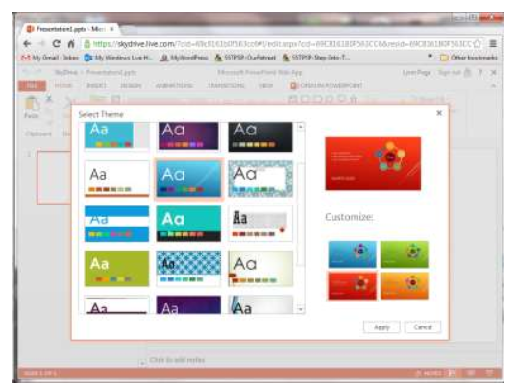
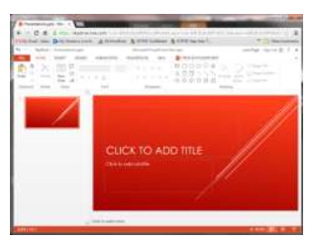
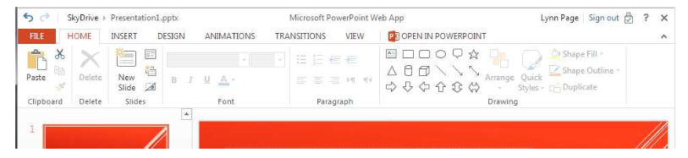

The Home tab has the Clipboard, Slides, Font, Paragraph and Drawings groups. The font and paragraph formatting commands are limited to the basic functions. The number of shapes is limited but you still have styles, fill and outline. I like the new Delete group as it provides one click option to delete a slide.

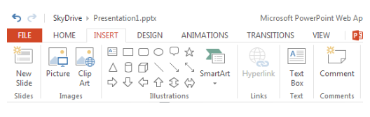
The Insert tab has a New Slide button to open the dialog to select a slide style to add to the presentation. Adding pictures and clip art is same as in the Word Web App. Shapes and SmartArt are added in the Illustrations group.

The Text group contains the Text Box icon.

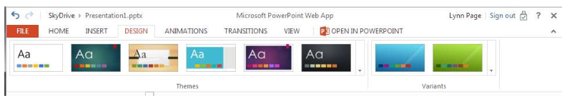
The Design tab offers the same themes and variations shown in creating the presentation. So if you decide that the selected theme isn’t working change it to one more suitable. Set the animation on the slide and timing or reorder the animations on the Animation tab. Slide transitions are limited to none, fade and push and are controlled on the Transitions tab. The View tab has three Presentation Views as well as Notes and Comments. The Editing View is the normal view you would use in PowerPoint with slide icons for selecting or sorting and the active slide pane. The other options are Reading View and Slide Show.

